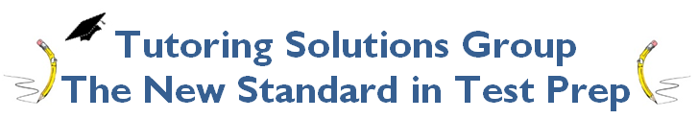
Lesson 9: Trigonometry, Imaginary Numbers, Geometry
- In a right triangle, one angle measures x°, where $\cos{x°}=\frac{5}{13}$ . What is $sin(90° -x°)$?
  - 0.385
  - 0.923
  - 0.417
  - 2.6

- In a right triangle, one angle measures x°$(x°≠90)$, where $\sin{x°}=\frac{24}{26}$ . What is $cosx°$?
  - 0.923
  - 0.385
  - 1.083
  - 0.417
- In the xy-plane below, O is at the center of the circle, and the measure of ∠AOB is $\frac{π}{a}$ radians. What is the value of a?
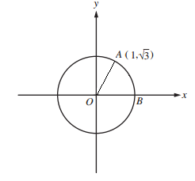
  - 6
  - 5
  - 4
  - 3
- In a right triangle, $\cos{\frac{π}{a}}=\frac{1}{2}$. What is the $\cos{\frac{2π}{a}}$?
  - 0.5
  - -0.5
  - 0.9
  - -0.9
- In triangle ABC, the measure of ∠B is 90°, BC = 8, and AC = 10. Triangle DEF is similar to triangle ABC, where vertices D, E, and F correspond to vertices A, B, and C, respectively, and each side of triangle DEF is 2 times the length of the corresponding side of triangle ABC. What is the value of $\cos{F}$?
  - 0.2
  - 0.6
  - 0.8
  - 1.0
- The angles shown above are acute and $\sin{a}=\cos{b}$. If $a=3k-7$ and $b=2k+17$, what is the value of k?
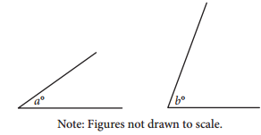
  - 12
  - 14
  - 16
  - 18
- If $\sin{30}=0.5$, $\cos{x}=0.5$. Find the value of x?
  - 60
  - 45
  - 30
  - 15
- In a circle with center O, central angle AOB has a measure of $\frac{7π}{6}$radians. The area of the sector formed by central angle AOB is what fraction of the area of the circle?
  - $\frac{π}{6}$
  - $\frac{1}{6}$
  - $\frac{7π}{12}$
  - $\frac{7}{12}$
- In a circle with center O, central angle AOB has a measure of $225°$. How many radians would be needed to complete the circle?
  - $\frac{π}{4}$
  - $\frac{3π}{4}$
  - $\frac{5π}{4}$
  - $\frac{7π}{4}$
- In a right triangle, $\sin{\frac{π}{a}}=\frac{1}{2}$. What is the $\sin{\frac{7π}{a}}$?
  - $\frac{1}{2}$
  - $\frac{π}{2}$
  - $-\frac{1}{2}$
  - $-\frac{π}{2}$

- The angles shown above are acute and $\sin{a}=\cos{b}$. If $a=5k-3$ and $b=7k+9$, what is the value of k?

  - 7
  - 5
  - 3
  - 2
- In a right triangle, one angle measures x°, where $\sin{x°}=\frac{8}{10}$ . What is $cos(90° -x°)$?
  - .4
  - .6
  - .8
  - 1.2
- In the xy-plane below, O is at the center of the circle, and the measure of ∠AOB is $\frac{π}{a}$ radians. What is the value of a?
  - 2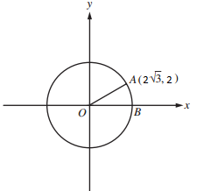
  - 3
  - 4
  - 6
- In a right triangle, $\tan{\frac{π}{a}}=1$. What is the $\tan{\frac{5π}{a}}$?
  - 1.00
  - 0.50
  - 0.87
  - -0.50
- If the expression below is rewritten in the form a+b, where a and b are real numbers, what is the value of a? (Note $i=\sqrt{-1}$)
$$\frac{7-i}{1-2i}$$
  - $\frac{7}{2}$
  - $\frac{9}{5}$
  - $\frac{13}{5}$
  - $\frac{9}{2}$
- In triangle ABC, the measure of ∠B is 90°, AB = 12, and AC = 13. Triangle DEF is similar to triangle ABC, where vertices D, E, and F correspond to vertices A, B, and C, respectively, and each side of triangle DEF is $\frac{1}{2}$ times the length of the corresponding side of triangle ABC. What is the value of $\tan{D}$?
  - 0.87
  - 0.42
  - 0.50
  - 0.39
- What is the value of $i^{39}$? (Note $i=\sqrt{-1}$)
  - $\sqrt{-1}$
  - $-$1
  - $-\sqrt{-1}$
  - $1$
- A rectangular object has a hole with the radius of 1 cm drilled through it. The base of the object is 2 cm, the length of the object is 3 cm, and the height of the object is 4 cm. The density of the object is 6.3 grams per cubic centimeter. What is the mass to the nearest gram?
  - 74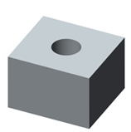
  - 75
  - 76
  - 72
- If the expression below is rewritten in the from a+b, where a and b are real numbers, what is the value of a? (Note $i=\sqrt{-1}$)
$$\frac{3-i}{4-2i}$$
  - $\frac{1}{10}$
  - $\frac{7}{10}$
  - $\frac{10}{7}$
  - $\frac{1}{7}$
- In the xy-plane below, O is at the center of the circle, and the measure of ∠AOB is $\frac{π}{a}$ radians. What is the value of $tan\frac{aπ}{4}$?
  - 1
  - -.5
  - -1
  - .5
- A triangular prism shaped object has a hole drilled all the way through in the shape of a rectangle with the side lengths of 1 cm and 2 cm. The sides of the triangular face are all 6 cm and the length of the object is 5 cm. The density of the object is 3.7 grams per cubic centimeter. What is the mass to the nearest gram?
  - 59
  - 61
  - 63
  - 65
- What is the value of $i^{25}$? (Note $i=\sqrt{-1}$)
  - $\sqrt{-1}$
  - $-$1
  - $-\sqrt{-1}$
  - $1$
- The angles shown above are acute and $\sin{a}=\cos{b}$. If $a=3k-4$ and $b=7k+4$, what is the value of k?

  - 7
  - 5
  - 6
  - 9
- In a right triangle, $\tan{x}=1$. What is the $\cos{7x}$?
  - 0.83
  - 0.71
  - 0.42
  - 0.92

