Lesson 8: Geometry
- $\overline{AB}=10$ and $\overline{AD}$ is 3 times as long as $\overline{DB}$. Find area of the shaded region.

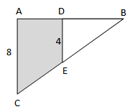

- A cube with the volume of 64 is inscribed in a sphere. Find volume of the sphere.

- Find all side lengths of $∆ABC$ and area.
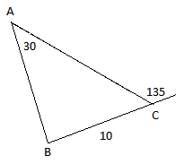
- Square ABCD is inscribed in the circle. $\overline{BC}=8$. Find area of the shaded region.
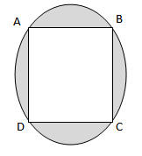

- Find a as a function of b and c.

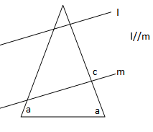

- Line q follows $3x-4y=8$. Line r is perpendicular to line q and passes through (7, 12) and (t, t+1). Find the value of t.

- Line a follows $5x+10y=30$. Line b is parallel to line a and passes through (-1, -8). Find the value for which line b intersects the y-axis.

- A large mosaic is 80in long and 60in wide. It is to be covered by smaller 2in x2in tiles. How many tiles are needed to cover the mosaic?

