Lesson 7: Problem Solving and Data Analysis
Graphs and Charts
Questions 1-4 refer to the following graph.
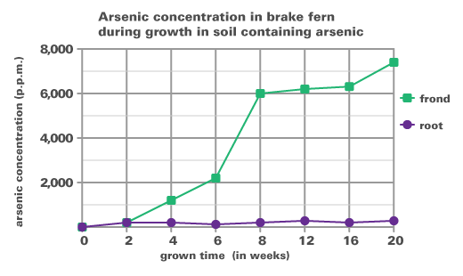
Scientists moved several brake fern plants from uncontaminated soil to soil containing 97 p.p.m (p.p.m. stands for parts per million, or one milligram arsenic per kilogram of soil or plant) arsenic. The concentration of arsenic was measured in the fern’s roots and fronds at various times for 20 weeks and recorded on the graph above. The point on the second week is at the coordinate (2, 200). Source: University of South Florida
- During what weeks is the greatest increase of arsenic concentration in the frond?
  - Weeks 4 to 6
  - Weeks 6 to 8
  - Weeks 12 to 16
  - Weeks 16 to 20

- Choose the true statements regarding weeks 4 to 6.
  - The concentration in the frond increases by about 50%.
  - The concentration in the frond increases by about 100%

  - The concentration in the frond is 2 times the concentration in the roots at 6 weeks.
  - The concentration in the frond is 4 times the concentration in the roots at 6 weeks.
- What does the graph represent from weeks 0 to 2?
  - The concentration of arsenic is greater in the frond.
  - The concentration of arsenic stays constant all throughout.
  - The concentration of arsenic increases at the same rate in the frond and the root.
  - None of the above.

- How much arsenic is concentrated in the whole brake fern plant at 2 weeks?
  - 200 ppm
  - 400 ppm
  - 600 ppm
  - There is not enough information given.

Questions 5-8 refer to the following graph.
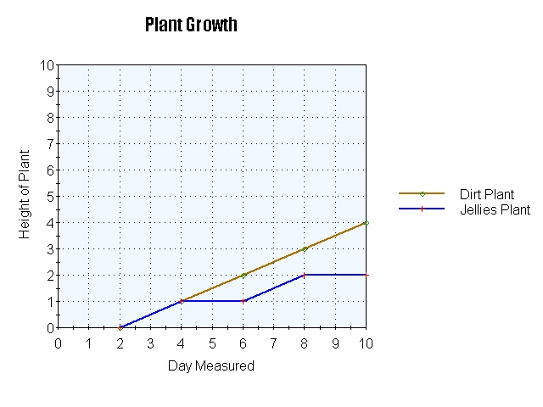
For a science experiment, a group of sophomores want to track the height (cm) of two plants rooted in different materials to see which material led to more growth. Recorded on the graph above are the heights over ten days for a plant grown in dirt and a plant grown in jellies. Source: NKSchools
- Choose the correct statement regarding the heights of the plants on Day 10.
  - The height of the dirt plant is 100% greater than the jellies plant.
  - The height of the jellies plant is 50% the height of the dirt plant.
  - Both A & B
  - None of the above

- If the dirt plant continues on the same trajectory, what will the height of the dirt plant be on Day 16?
  - 6 cm
  - 7 cm
  - 8 cm
  - 9 cm

- What is true about the growth from Day 8 -10?
  - The dirt plant is increasing at a higher rate than the jellies plant.
  - The jellies plant is increasing at a higher rate than the dirt plant.
  - Both plants are increasing at the same rate.
  - The dirt plant has stagnated in growth.

- If the jellies plant continues to follow the same pattern the graph currently shows, what will the height be on Day 16?
  - 3
  - 4
  - 5
  - 6

Questions 9-12 refer to the following graph.
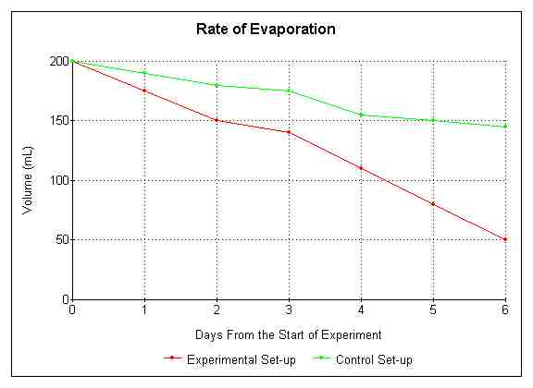
A science experiment was conducted to see how water evaporates and the data was collected in the graph pictured above. The volumes of two water basins were measured over a period of 6 days. Both basins originally contained 200 mL of water. The higher line was the control in which the water was placed on a tabletop. The lower line was the experimental in which the water was placed on a hot plate. Source: PFlommScience
- At which point is 75% of the water in the basin on the hot plate evaporated?
  - Day 2
  - Between Days 2 and 3
  - Between Days 4 and 5
  - Day 6

- When is the volume of the basin on the hot plate about half the volume of the basin on the tabletop?
  - Day 3
  - Day 4
  - Day 5
  - Day 6

- If both basins had been combined into one entity, on which day would about 50% of the total volume evaporate?
  - Day 4
  - Day 5
  - Day 6
  - Not shown on the graph

- What is true at the end of the 6 day experiment?
  - The volume of the experimental setup is about $\frac{1}{3}$ of the volume of the control set up.
  - The volume of the experimental setup is about $\frac{1}{4}$ the volume of the control set up.
  - The water in the control set up evaporated at a much higher rate than the experimental set up.
  - None of the above

Questions 13-16 refer to the following graph.
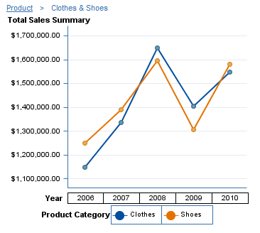
The sales summary of clothes and shoes for a company was recorded for five years and graphed above. Source: SAS Institute
- What time period had the greatest increase in shoe sales?
  - 2006 to 2007
  - 2007 to 2008
  - 20008 to 2009
  - 2009 to 2010

- What time period had the greatest increase in clothes sales?
  - 2006 to 2007
  - 2007 to 2008
  - 20008 to 2009
  - 2009 to 2010

- What was about the total sales of shoes and clothes during the company’s best year?
  - $3350000
  - $3250000
  - $1650000
  - $1600000

- Choose the correct statement regarding the sales of 2009.
  - The shoe sales were about 3% of the clothes sales.
  - The clothes sales were about 3% of the shoe sales.
  - The shoe sales were about 97% of the clothes sales.
  - The clothes sales were about 97% of the shoe sales.

Questions 17-20 refer to the following graph.
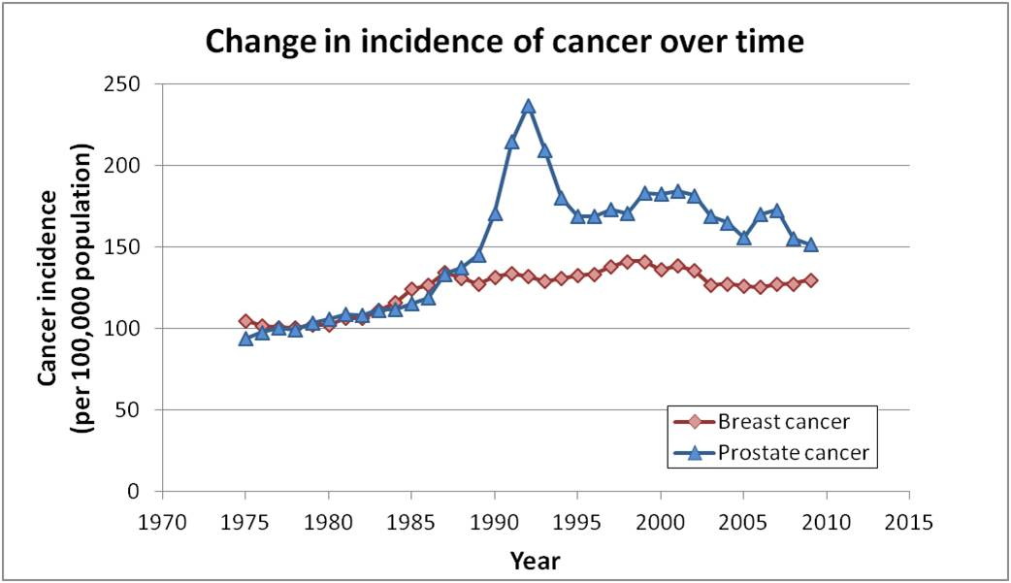
The graph above displays data of the number of cancer incidences from 1970 to 2015. Both breast cancer and prostate cancer are studied. Source: Katatrepsis
- In the most general view, how are the incidences of both prostate cancer and breast cancer changing over time?
  - Decreasing then increasing
  - Increasing
  - Decreasing
  - Not enough information given

- Choose the correct statement regarding the interval Year 1990 to 1995.
  - There were more incidences of breast cancer than prostate cancer in this time period.
  - The number of incidences of prostate cancer increased by over 100% since 1975 in this time period.
  - There is a peak in breast cancer incidences during this time.
  - None of the above

- During which time period is the number of incidences of prostate cancer 0.1% of the 100,000 people population?
  - 1975 to 1985
  - 1985 to 1995
  - 1985 to 1995
  - 1995 to 2015

- During which time period is the number of incidences of cancer is 0.2% of the 100,000 people population?
  - 1975 to 1985
  - 1985 to 1995
  - 1985 to 1995
  - 1995 to 2015

