Lesson 4: Geometry and Passport to Advanced Math
1. In the following equation, find the radius and express the equation in standard form:
$$x^{2}+y^{2}+6x-12y=-1$$

2. If f(6)=8, f(9)=4, g(4)=10, and g(3)=6, find f(g(3)).

3. $Write the following equation in an equialent form to clearly display the x intercepts.$
$$y=x^{2}-12x+8.$$

4. $Let a,b,and c all represents constants in the following equation. 3\left(x+7\right)+4x\left(5x-8\right)=ax^{2}+bx+c.$ Find all values of b.

5. Find the sum of all values of m in the following 2 equations.
$$0=2m^{2}-16m+8 and$$
$$0=4m^{2}-12m+16$$

6. $A standard rate for frogs \left(R\right)can be expressed in terms of$
$$nominancy \left(N\right)and frequency \left(F\right).$$
$$Find an expression for frequency in terms of standard rate and nominancy.$$
$$R=\frac{F}{2(N+F)}$$
7. If $\frac{x^{m^{2}}}{x^{n^{2}}}=x^{20}, and m+n=6, find the value of m-n.$

8.
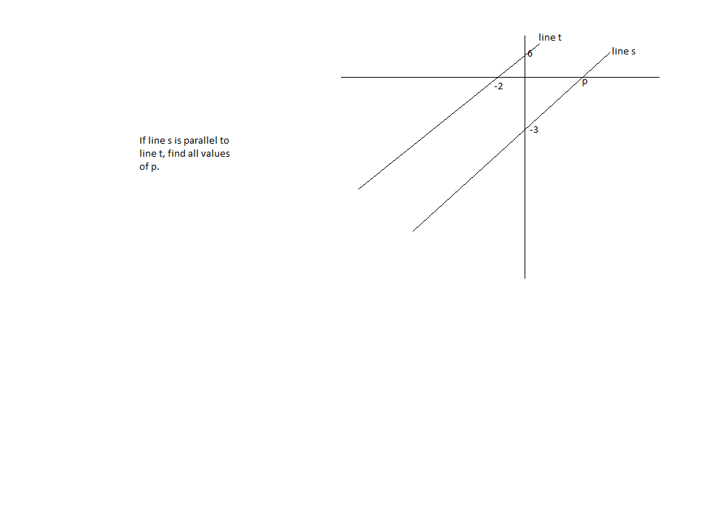

9. ${If 4}^{2b-8}=y^{3a+7} and y has a value of 8, find an expression for b in terms of a.$

10. In the following line y=Lx+5, if the line passes through (c,d) and c and d are both constants, find an expression for l in terms of c and d.

11. Find a value for k such that equations i and ii have no solutions.
(i) $kx-3y=4$
$$\left(ii\right)4x-8x=9$$

12. In the following quadratic
$$y=m\left(x-3\right)\left(x+6\right)and the vertex is \left(c,d\right).Find the value of c.$$

13. in the polynomial, $4x^{2}-10x+9 find all roots.$

14. $y=mx^{2}+12x+6.If the vertex is \left(-4, t\right), find the value of m.$

15. Graph the following quadratics. Find the roots and vertex
A .$y-8={\left(x+\frac{5}{2}\right)}^{2}$

B. $y=-\frac{1}{3}x^{2}+10x+8$

C.$y=8x^{2}-5x-20$

16. $g\left(x\right)=3x^{2}+cx+15, The ordered pair, \left(4,9\right)lies on the graph of g\left(x\right).Find the value of c.$

17. $\frac{7}{8}x-\frac{3}{8}x=\frac{3}{7}+\frac{2}{15}.Find the value of x.$

18. $4m^{3}\left(m^{2}-6\right)=-8m.Find all real values of m.$

19. Sum the following polynomials.
$$8x^{2}- 15x+13$$
$$-9x^{2}-13x-27$$

20. $If h=-30t^{2}+Lt+z, find an expression for L in terms of h, t, and z.$

21. $Find the area of the circle:{\left(x-3\right)}^{2}+{\left(y+7\right)}^{2}=50.Graph the circle also.$

