Lesson 2: Heart of Algebra Simplifying, Problem Solving, Geometry
1. An agent receives a commission of 40 cents for every $50 of business she procures. What percent is the agent's commission?
(A) 0.8%
(B) 1.0%
(C) 1.25%
(D) 1.5%
(E) 2.5%

2. Mindy’s average monthly salary for the first 4 months she worked was $300. What must her average salary for the next 8 months be so that her average monthly salary for the year is $350?
(A) $400
(B) $380
(C) $390
(D) $375
(E) $370

3. If increasing 20 by P percent gives the same result as decreasing 60 by P percent, what is P percent of 70?

4. In a downtown building, there are 6 floors and the number of rooms on each floor is R. If each room has exactly C chairs, which of the following gives the total number of chairs in the building?
(A) 6RC
(B) 6R+C
(C) 6/RC
(D) 6R+6C
(E) .6RC

5. 2³⁰ + 2³⁰ + 2³⁰ + 2³⁰ =
(A) 8¹²⁰
(B) 8³⁰
(C) 2³²
(D) 2³⁰
(E) 2²⁶

6. If the average of 27-x, x-8, and 3x+11 is y, what is the average of 2y and 2y/3?
(A) 4x+40
(B) x+10
(C) (8x+80)/3
(D) (4x+40)/3
(E) (2x+20)/3

7. 3⁵ + $\frac{1}{3^{5}}$=

(A) 1
(B) 3
(C) $\frac{3^{6}-1}{3}$
(D) $\frac{3^{10}+1}{3^{5}}$
(E) $\frac{3^{25}}{3^{5}+1}$

8. A special lottery is to be held to select the student who will live in the only deluxe room in a dormitory. There are seniors, juniors, and sophomores who applied. Each senior's name is placed in the lottery times; each junior's name, times; and each sophomore's name, time. What is the probability that a senior's name will be chosen?

(A) 1/8
(B) 2/9
(C) 2/7
(D) 3/8
(E) 1/2

9. The population of Katysville in year 1900 was 1,200. Since then, the population has doubled every 14 years. If n is the number of people living in Katysville and t is the number of years since 1900, which of the following represents the number of people in Katysville after 1900?
(A) 1200(2^{t})
(B) 1900(2¹⁴)
(C) 1200(2^{t/14})
(D) 1200(2^{14t})
(E) 1900(14/t)

10. The cost to rent a boat for a fishing trip is x dollars, which is to be shared equally among the people taking the trip. If 12 people go on the trip rather than 20 people, how many more dollars, in terms of x will it cost?
(A) x/8
(B) x/12
(C) x/16
(D) x/20
(E) x/30

11. Radio House paid $60 for a CD player. At what price should it be offered for sale if the store offers customers a 10% discount but still wants to make a profit of 20% on the cost?
(A) $64.80
(B) $72
(C) $79.20
(D) $80
(E) $84.20

12. Simplify $\frac{\frac{1}{x}-\frac{1}{y}}{\frac{1}{x}+\frac{1}{y}}$
(A) $\frac{x-y}{x+y}$
(B) $\frac{x+y}{x-y}$
(C) $\frac{y-x}{x+y}$
(D) -1
(E) -xy

13. If $\frac{1}{a}-\frac{1}{b}=6 and \frac{1}{a}+\frac{1}{b}=5, find \frac{1}{a^{2}}-\frac{1}{b^{2}}$
(A) 30
(B) -11
(C) 61
(D) 11
(E) 1

14. 4^{n}+4^{n}+ 4^{n}+ 4^{n} =
(A) 4^{4n}
(B) 16^{n}
(C) 4^{(n*n*n*n)}
(D) 4^{(n+1)}
(E) 16^{4n}

15. Which of the following does not intersect y=5x+2?
(A) -5x+2y=4
(B) -2x+5y=-3
(C) 10x-y=1
(D) 3x+y=17
(E) 5x-y=-29

16. A toy factory manufactures d dolls every hour. Each doll costs c cents. How many dollars will the factory spend in costs for manufacturing dolls in 7 hours and 30 minutes?
(A)3cd/40
(B) cd/100
(C) 7cd/100
(D) cd/750
(E) 15cd/100

17.How many cylindrical oil drums, with a diameter of 1.5 feet and a height of 4 feet would be needed to hold the contents of a full cylindrical fuel tank with a diameter of 12 feet and a height of 60 feet?
(A) 640
(B) 720
(C) 840
(D) 880
(E) 960

18.What is the volume of a cube whose surface area is 96?
(A) 16$\sqrt{2}$
(B) 32
(C) 64
(D) 125
(E) 216

19.What is the slope of a line containing points (4,6) and (3,8)?
(A) -2
(B) -.5
(C) 0
(D) .5
(E) 2

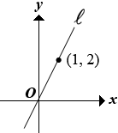
20.In the plane above, line contains the points and . If line (not shown) contains the point and is perpendicular to , what is an equation of ?

(A) y= -.5x
(B) y= -.5x+1
(C) y=-x
(D) y= -x+2
(E) y= -2x

21.Line l contains the points (3,1) and (4,4). If line m is a different line, parallel to line l in the same coordinate plane, which of the following could be the equation of line m?

(A) y=3x-8
(B) y=1/3x - 3
(C) y= -3x - 8
(D) y=3x+1
(E) y= -8x+

22.If 6x - 3y = 30 and 4x = 2 - y then find x + y

23.Sara has some oranges. She sold 40% more than she ate. If she sold 70 oranges, how many did she eat?

24.

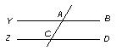(YB is parallel to ZD)
If BAC = (a + 30) degrees, then ACD expressed in terms of a is:
(A) a + 30
(B) a + 150
(C)150 - a
(D) 60 + a
(E) a - 60

25. Samuel is trying to model a linear relationship between the hours of homework he does each night (H) and his grades in school (G). He finds that when he does not study at all, he still has an average of 65. Even though he realizes this, he wants to do better and thinks that spending more hours doing homework every night will improve his grades. He eventually discovers that spending 5 hours per night on homework results in an average of 95 in school. Find the equation for this situation.
A) 5G-H=95
B) 4G-6H=120
C) G-5H=65
D) 2G-12H=130
E) 6G-5H=95

26. A mountain climber needs to prepare for his hike up the mountains of Nevada so he researches the temperature. He finds the following graph which relates the elevation to the temperature. What is the correlation between elevation and temperature?
  - Positive Correlation
  - Negative Correlation
  - No Correlation
  - Parabolic Correlation
  - Not enough data available
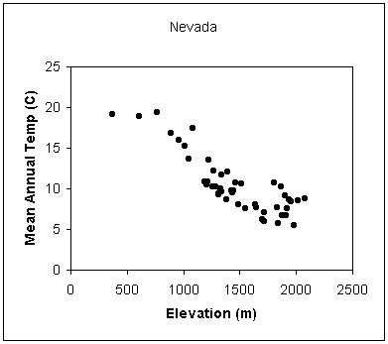

27. Which of the values is closest to the average temperature decrease per meter according to the line of best fit?
- 0.001
- 0.01
- 0.1
- 1
- 10

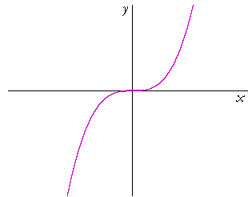
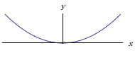
28. Which of the following could be the graph of y=5x³-8x⁴+2x²-cx+d?

A.

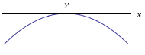
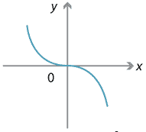
B.

C.

D.

http://www.cpp.edu/~jcclark/classes/old/bio256/b256a9.html

